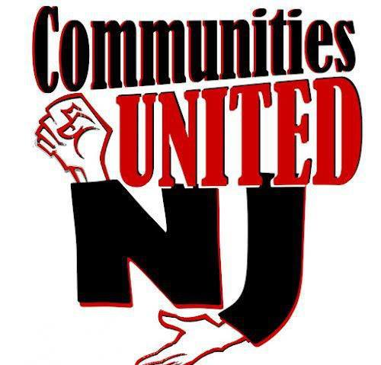

Notice of PARCC Assessment Refusal—New Jersey
Common Core-aligned PARCC assessments, which are scheduled to be administered this year to New Jersey students in grades 3-11, are a detriment to the State’s children, teachers, and schools for the following reasons:

- PARCC assessments are created and scored by Pearson, a for-profit corporation with a decades-long history of test-construction and test-scoring errors.
- Despite their claim to “see how children are progressing in school and whether they are on track for postsecondary success,” PARCC assessments are neither accurate measures of student learning nor appropriate predictors of a child’s postsecondary success or failure.
- The costs associated with PARCC assessments are exorbitant and largely unfunded—and have forced many districts to cut essential programs and personnel.
- PARCC assessments do not provide students and teachers with any type of meaningful feedback.
- PARCC assessments consume an unreasonable amount of instructional time.
- The PARCC online assessments are difficult to manipulate, and student struggles with the PARCC interface will be reflected in scores.
- Research clearly suggests that standardized assessments like PARCC disproportionately and negatively affect minority, socioeconomically-disadvantaged, special needs, and English language learner populations.
- When school ratings and teacher evaluations are tied to standardized test scores, teachers are virtually forced to replace meaningful learning with test preparation.
- Online assessments require districts to share student information beyond what is reasonable and appropriate.
- The act of determining cut scores after students have taken standardized assessments, presumably for the purposes of achieving predetermined passing and failure rates, is inherently flawed.

As such, I/we, __________________________________________refuse to allow our child(ren), ____________________________________________, to participate in the following:

- PARCC Performance-Based Assessments
- PARCC End-Of-Year Assessments
- Any test-prep activities, computer- or paper-based, associated with or designed to prepare for PARCC assessments

In addition, I/we refuse to allow our child(ren) to participate in other standardized tests (check all that apply):

- New Jersey Assessment of Skills and Knowledge (NJASK)-- Science (grades 4 & 8)
- New Jersey Biology Competency Test (NJBCT)
- Other ___________________________________________________________
Because New Jersey Education Commissioner David Hespe stated that it is up to individual districts to determine how to handle refusals, we expect that our child(ren) will not be punished for our decision to refuse testing. Further, as per the 2015 PARCC Spring Test Coordinator Manual, we expect that our “non-testing student” will be provided with alternative placement outside the testing environment and permitted to read, do enrichment work, etc.

This document shall serve as formal, written notification of our wishes.

Parent/Guardian Name(s)___________________________________________________________

Parent/Guardian Signature(s)_______________________________________________________ Date____________________________

Parent phone__________________________________________________________________________

Parent email___________________________________________________________________________
For more information on refusing PARCC testing, see www.saveourschoolsnj.org/refusing-parcc-test

